

### CMS:[023-23-0314]

### SEC :[A]

### Name:[AZHAR ALi]

* Task: Your task is to understand the working and structure of a generic linked list and then Implement it. Submit the JAVA code.

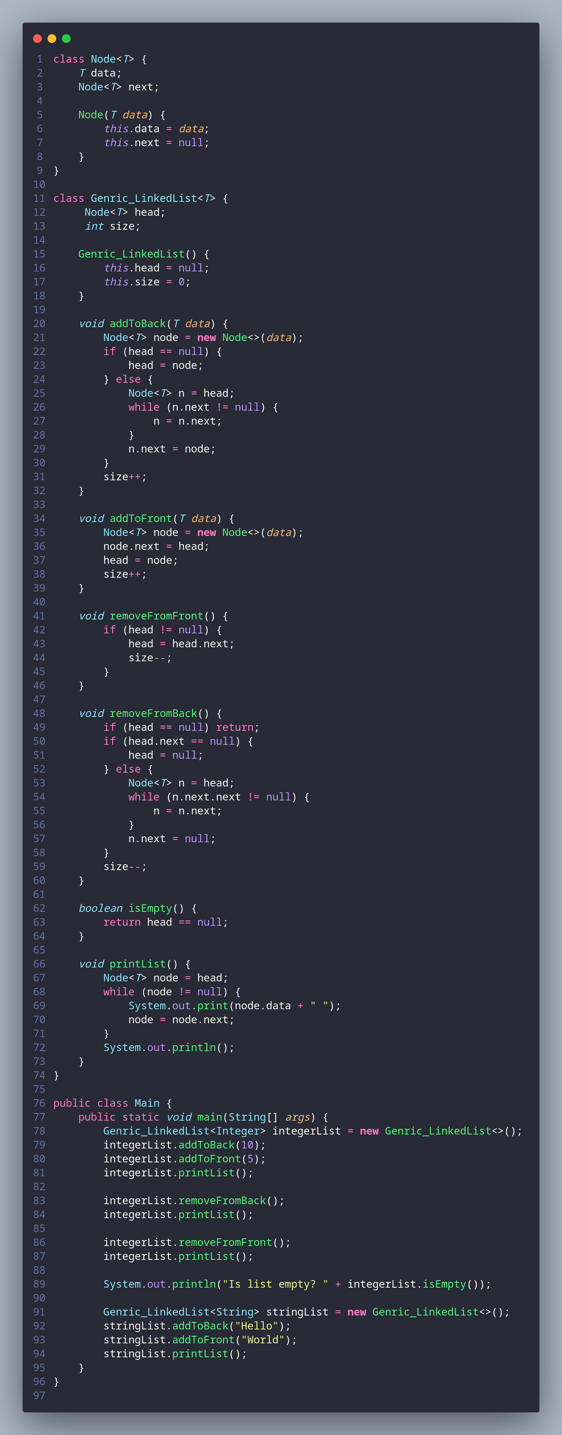

**REMOVE FROM FRONT METHOD**

**ADD TO FRONT METHOD**

**Genric Class**

**PRINTLIST () METHOD**

**ISEMPTY() METHOD**

**REMOVE FROM BACK METHOD**

**ADD TO BACK METHOD**

**NODE CLASS**

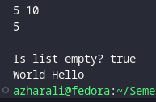

**OUTPUT**

**MAIN METHOD**